Name & Surname | Student No.
Soko K. Mpotulo | 240010337
Lingani Lelethu | 223105740
Matinisi Lubisi | 222527269
Simamkele Makuzeni | 240184866
Lusani Magadani | 222026944
Samkelo Mbekwa | 221737006
PROJECT 1 (PRT152S)

Class: 1G
Subject Code: PRT152S
Task: ASSESSMENT 3
DUE DATE: 27 Oct. 2024

Project Documentation

Project Charter (Updated and Complete)
Project Name: Bright Future Foundation NGO Website Project
Start Date: 2024/09/01
End Date: 2024/10/02
Budget: Time and resources only (no monetary budget)

Business Case:
The Bright Future Foundation works to improve community development by implementing programs related to environmental sustainability, health, and education. The creation of a strong, user-friendly website would greatly expand the NGO's reach, encourage volunteer participation, and simplify the donation procedure. Additionally, the website will function as a venue for showcasing ongoing initiatives, increasing transparency and drawing additional community and stakeholder participation.

Purpose:
The goal of this project is to create a responsive, dynamic, and fully functional website for the Bright Future Foundation. This website will enable volunteer sign-ups, facilitate donations, and provide a platform for inquiries in addition to providing details about the NGO's vision, goals, and programs.

Organization’s Mission and Vision:
Mission: To empower communities by implementing long-term, environmentally, health, and education-related projects.
Vision: To bring about a future in which environmental stewardship, health care, and education enable every community to prosper.

Scope:
- Boundaries: The project will include the design and development of the NGO's website, but it will not cover any post-launch maintenance or updates.

- Deliverables:
Home Page, About Us Page, Projects Page, Volunteer Sign-Up Form, Donation Page, Contact Us Page.

- Acceptance Criteria:
Fully functional website with responsive design, all specified pages, forms, and interactive elements.

Goals/Objectives:
- Develop a visually appealing website with complete functionality.
- Ensure user-friendly navigation and form submissions.
- Add interactive elements using JavaScript.

User Requirements:
- Easy navigation
- Accessible and responsive design
- Functional forms for volunteering, donations, and contact

System Requirements:
- HTML, CSS, JavaScript for front-end development
- Hosting environment (e.g., local server or web hosting)

Technical Aspects:
- HTML5 for structure
- CSS3 for styling
- JavaScript for interactivity and validation
Resources:
- Development tools: VS Code, web browsers for testing
- Content: Text and images for the NGO

Key Stakeholders:
- Project Team (Developers)
- NGO Representatives
- End Users (Volunteers, Donors, General Public)

Roles and Responsibilities:
- Project Manager: Oversees progress, ensures deadlines are met.
- Developers: Create HTML, CSS, JavaScript.
- Content Providers: Provide website text and images.

Risks and Risk Management:
- Technical Issues: Potential bugs or compatibility issues
Solution: Conduct thorough testing.

- Time Constraints: Limited project timeframe
Solution: Schedule regular team check-ins.
- Team Availability: Scheduling conflicts
Solution: Implement a flexible schedule.

Communication Protocols:
- Regular team updates through meetings and email
- Documentation of progress and issues

Key Milestone Schedule:
- Project Kick-off: 2024/09/01
- Completion of HTML Structure: 2024/09/10
- Completion of CSS Styling: 2024/09/20
- JavaScript Functionality Complete: 2024/09/25
- Testing and Review: 2024/09/28
- Submission: 2024/10/02

Wireframes in Table Format
Page | Section | Content/Elements | Description
Home Page | Header | Logo, Navigation Menu | Includes NGO logo and links to other pages (Home, About, Projects, etc.)
 | Welcome Section | Welcome Message, Background Image | A welcoming message for visitors with a large, friendly background image
 | Intro Section | Brief Mission Statement | Quick overview of what the NGO stands for and its primary mission
 | Footer | Contact Info, Social Media Links | Contact details, social links, and a copyright notice
About Page | Header | Logo, Navigation Menu | Consistent across all pages
 | Mission & Vision | Text Content, Supporting Image | Detailed mission and vision statements of the NGO
 | Team Section | Images, Names, Short Bios of Team Members | A showcase of key people behind the NGO with brief bios
 | Footer | Contact Info, Social Media Links | Standard footer
Projects Page | Header | Logo, Navigation Menu | Consistent with other pages
 | Project Listings | List of Projects, Brief Description, Links | Each project includes a title, short description, and a link for more details
 | Project Images | Image Gallery | Visual gallery of project highlights
 | Footer | Contact Info, Social Media Links | Standard footer
Volunteer Page | Header | Logo, Navigation Menu | Consistent across all pages
 | Volunteer Info | Why Volunteer, Benefits, Volunteer Stories | Section highlighting the value of volunteering with the NGO
 | Sign-Up Form | Name, Email, Phone, Submit Button | Form to capture volunteer details with a "Submit" button
 | Footer | Contact Info, Social Media Links | Standard footer
Donation Page | Header | Logo, Navigation Menu | Consistent across all pages
 | Donation Details | How Donations Help, NGO Transparency Statement | Explanation of donation use and impact statement
 | Donation Form | Name, Email, Amount, Payment Options, Submit Button | Form to capture donor details and payment information
 | Footer | Contact Info, Social Media Links | Standard footer
Contact Page | Header | Logo, Navigation Menu | Consistent with other pages
 | Contact Form | Name, Email, Message, Submit Button | Simple form for visitor inquiries
 | Map | Embedded Google Map | Shows location of the NGO’s main office
 | Footer | Contact Info, Social Media Links | Standard footer

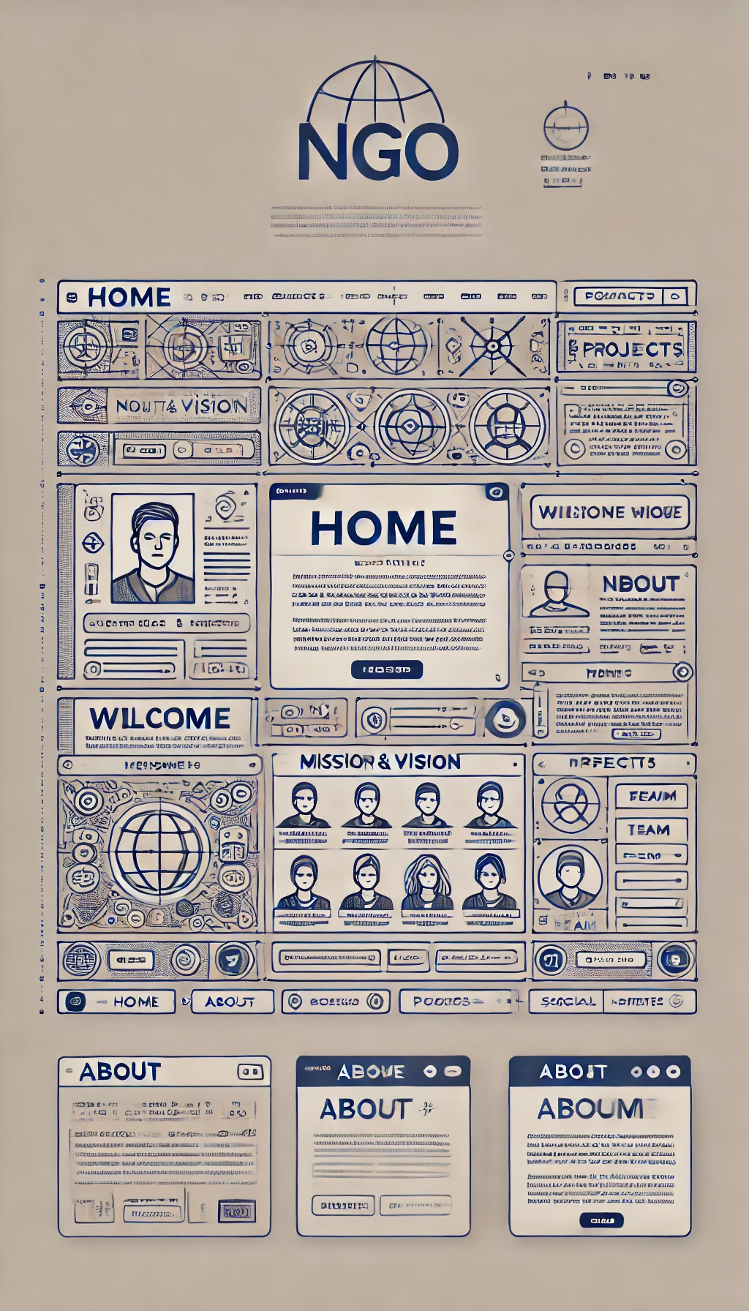
Design Aspects

Form Styling
- Contact, Search, Donate, and Subscribe Forms
- Utilizes a clean and modern aesthetic by applying a consistent background colour (var(--white-colour)) for input fields.
- Search functionality is enhanced with an easily accessible button positioned within the input field for intuitive user interaction.
- Hover effects on buttons provide feedback, improving usability.

Footer Design
- Site Footer
      - Features a visually distinct footer area with a background colour (var(--site-footer-bg-colour)) that separates it from the main content.
      - The footer is organized into sections with adequate padding to ensure readability and a professional appearance.
      - Links within the footer change colour on hover, enhancing user engagement and interaction.

Menu Structure
- Footer Menu
      - Designed with a two-column layout to present links in an organized manner, allowing users to navigate easily to different sections.

Social Media Integration
- Social Icons
      - Icons are styled to be visually appealing with a consistent background colour and hover effects, encouraging users to engage with social media channels.

Responsive Design
- Media Queries
      - Implemented to ensure the website is fully responsive across various screen sizes (1600px, 1170px, 991px, 580px, 480px).
      - Font sizes, paddings, and element dimensions are adjusted to maintain usability and readability on mobile devices.
      - Special attention is given to important elements, such as hero sections, carousels, and footer menus, ensuring they adapt gracefully to smaller screens.

Accessibility Considerations
- Focus Styles
      - Incorporation of focus styles for form elements (not currently in the CSS) is recommended to enhance keyboard navigation, catering to users with disabilities.

Colour Palette and Typography
- Consistent Use of Variables
      - The design employs CSS variables (var(--variable-name)) for colours, font sizes, and other styling properties, promoting consistency throughout the project.
      - The choice of colours and typography is aimed at ensuring a professional and approachable aesthetic, aligned with the foundation’s mission.

User Experience (UX) Enhancements
- Interactive Elements
      - The hover effects on buttons and links provide visual feedback, enhancing the overall user experience.
      - Proper spacing and layout design contribute to a more intuitive navigation experience.

Gantt Chart

Simplified Gantt chart overview of tasks:
Task | Start Date | End Date | Milestone
HTML Structure Creation | 2024/09/01 | 2024/09/10 | Milestone 1
CSS Styling Implementation | 2024/09/11 | 2024/09/20 | Milestone 2
JavaScript Functionality | 2024/09/21 | 2024/09/25 | Milestone 3
Content Creation & Upload | 2024/09/11 | 2024/09/25
Testing | 2024/09/26 | 2024/09/28 | Milestone 4
Review & Feedback | 2024/09/28 | 2024/09/30
Submission Preparation | 2024/10/01 | 2024/10/02 | Final Submission

Risk Management
- Technical Issues: Managed by testing and using standard best practices.
- Time Constraints: Adjusted tasks based on team availability and buffer time for delays.
- Scheduling Conflicts: Flexibility in deadlines, frequent communication to coordinate tasks.

Conflict Management
Conflicts were resolved by:
- Using a shared group chat for continuous communication.
- Referring to project goals and tasks to maintain focus.
- Implementing a voting system for major decisions.

Reflection Report (Group)
- Experience: Each member contributed unique skills, which enriched the project.
- Issues Encountered: Time management, integrating content, and gathering feedback.
- Problem Solving: Utilized version control and had regular review sessions.
- Lessons Learned: Early planning is crucial; allocate extra time for testing and refinement.
- Suggestions for Improvement: Allocate more time for testing and user feedback.

Agenda and Minutes of Meetings
Sample Meeting Record:
- Date: [2024/10/15]
- Agenda: Review of completed tasks, upcoming deadlines, any blockers
- Minutes:
      - Discussion on progress
      - Assignment of next tasks
      - Decision to adjust timelines as needed

